2- Reflection
Let us find the images of the standard basis vectors $e_{1}, e_{2}$ for $R^{2}$ in column form.
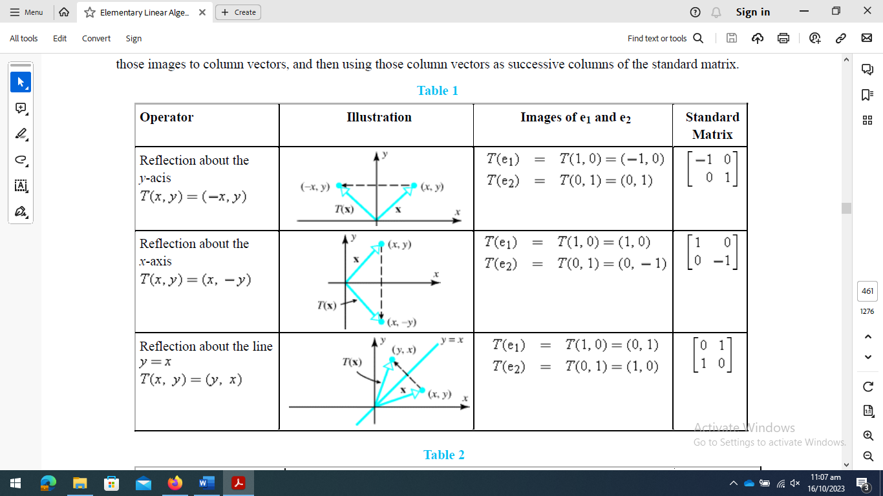
Example 1. (Reflection of Triangle)
Reflect the triangle with vertices A= (2, 4), B = (2, 2), C = (6, 2) along x-axis, y-axis and y = -x.
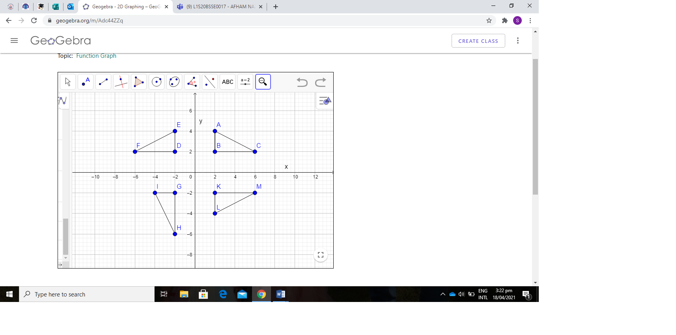
Example 2. (Reflection of a line)
Let y = 2x +1 be a line. Find the reflection of that line along the line y = x.
Solution. Here
A = $\left[\begin{matrix}0 & 1 \\ 1 & 0\end{matrix}\right]$
Therefore, T ($\vec{x}$) = A$\vec{x}$
$\left[\begin{matrix}x' \\ y'\end{matrix}\right]$= $\left[\begin{matrix}0 & 1 \\ 1 & 0\end{matrix}\right]$ $\left[\begin{matrix}x \\ y\end{matrix}\right]$ = $\left[\begin{matrix}y \\ x\end{matrix}\right]$
So, $x$ =$y'$, $y$ = $x'$
Y
X
y = 2x+1
$y^{'}$ = ½ $x^{'}$-1/2
Put x and y in original line y = 2x + 1
$x'$ = 2$y'$ + 1
Or 2$y'$ = $x'$ - 1
So $y'$ = 1/2 $x'$ - 1/2 is the reflected line.
To draw original line y = 2x + 1 take two points on it, let A = (1, 3) and B = (2, 5).
And to draw the Reflected line $y'$ = ½ $x'$ - ½, $A'$ = (2, 1/2) and $B'$ = (4, 3/2).
Reflection of circle
Let (x-2)² + (y-3)² = 4 be a circle. Find its reflection along the line y = -x
Solution.The transformation of reflection is
T ($\vec{x}$) =A$\vec{x}$, $∀$ $\vec{x}$∈R²
Where
A = $\left[\begin{matrix}0 & -1 \\ -1 & 0\end{matrix}\right]$
So, $\left[\begin{matrix}x' \\ y'\end{matrix}\right]$= $\left[\begin{matrix}0 & -1 \\ -1 & 0\end{matrix}\right]$ $\left[\begin{matrix}x \\ y\end{matrix}\right]$=$\left[\begin{matrix}-y \\ -x\end{matrix}\right]$
$⇒$ $\begin{matrix}x^{'}=-y \\ y^{'}= -x\end{matrix}$
Putting $x$ =$-y^{'},$ $y$ = $-x'$ in the original circle (x - 2)² + (y - 3)² = 4, we get
${(x}^{'}+ 3)$² + $(y^{'}+2)$² = 4, reflected circle.
As original circle (x - 2)² + (y - 3)² = 4 is with Centre = (2, 3) and Radius = 2
While Reflected circle ${(x}^{'}+ 3)$² + $(y^{'}+2)$² = 4 has Centre = (-3, -2), Radius = 2. We can draw both circles easily.
3-Rotation
Rotation about origin through an angle $θ$ is a transformation $T:R^{2}→R^{2}$defined as:
$$T\left(\vec{x}\right)=A\vec{x} : ∀\vec{x}∈R^{2}$$
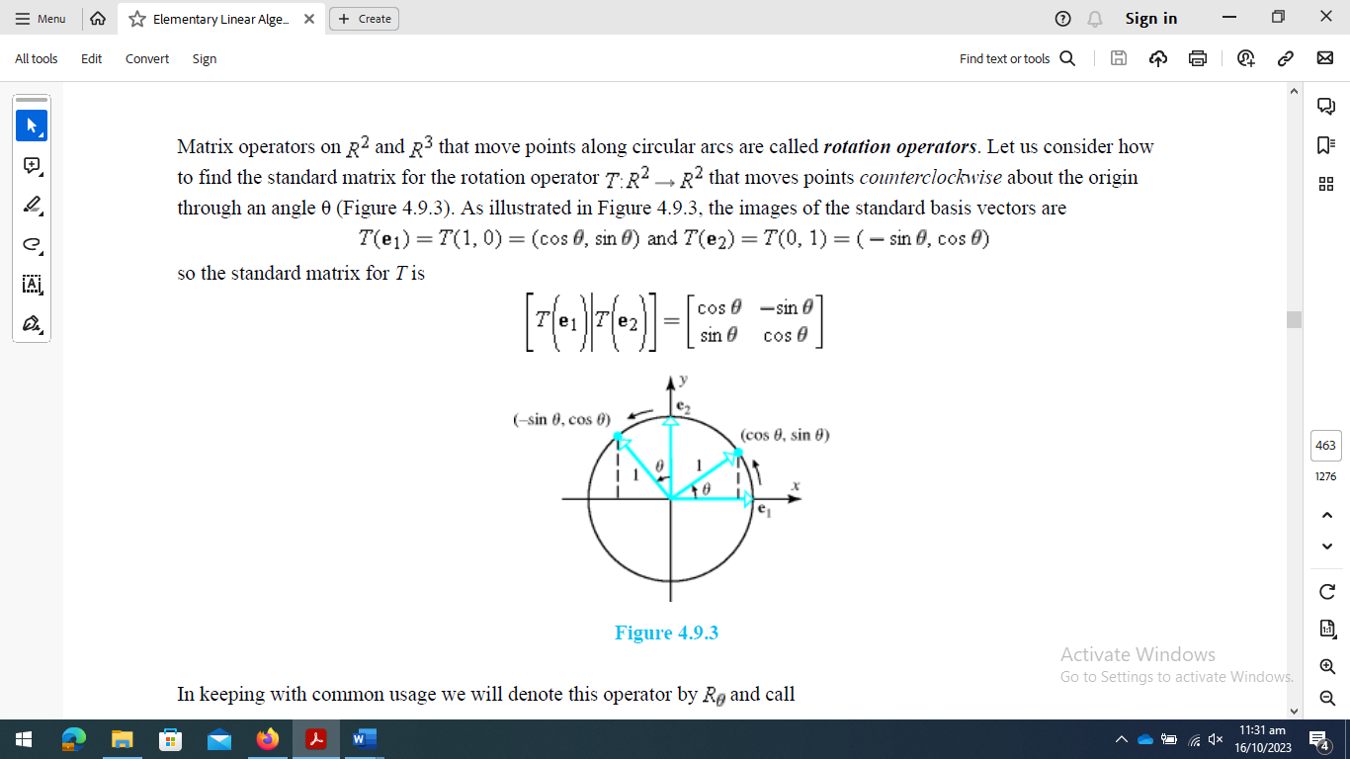

Where

$$A=\left[\begin{matrix}Cos(θ) & -Sin(θ) \\ Sin(θ) & Cos(θ)\end{matrix}\right]$$

- If the direction of $θ$ is not defined, then it is understood to be in anticlockwise direction.
- If $θ$is in clockwise direction, then replace $θ$by $-θ$ in the above definition as:

$A=\left[\begin{matrix}Cos(θ) & Sin(θ) \\ -Sin(θ) & Cos(θ)\end{matrix}\right]$
Example 1: Sketch the image of given rectangle with vertices A(0,0), B(3,0), C(3,2), D(0,2) under the rotation of $30^{0}$ (anticlockwise).
Solution: As the transformation of rotation is
$$T\left(\vec{x}\right)=A\vec{x} :∀\vec{x }∈R^{2}$$
Where
$$A=\left[\begin{matrix}Cos(θ) & -Sin(θ) \\ Sin(θ) & Cos(θ)\end{matrix}\right]$$
As $θ={30}^{0}$, so
$$A=\left[\begin{matrix}Cos({30}^{0}) & -Sin({30}^{0}) \\ Sin({30}^{0}) & Cos({30}^{0})\end{matrix}\right]=\left[\begin{matrix}\frac{\sqrt{3}}{2} & -\frac{1}{2} \\ \frac{1}{2} & \frac{√3}{2}\end{matrix}\right]$$
For point A: $T\left[\begin{aligned}0 \\ 0\end{aligned}\right]=\left[\begin{matrix}\frac{\sqrt{3}}{2} & -\frac{1}{2} \\ \frac{1}{2} & \frac{√3}{2}\end{matrix}\right]\left[\begin{aligned}0 \\ 0\end{aligned}\right]=\left[\begin{aligned}0 \\ 0\end{aligned}\right]$
For point B: $T\left[\begin{aligned}3 \\ 0\end{aligned}\right]=\left[\begin{matrix}\frac{\sqrt{3}}{2} & -\frac{1}{2} \\ \frac{1}{2} & \frac{\sqrt{3}}{2}\end{matrix}\right]\left[\begin{aligned}3 \\ 0\end{aligned}\right]=\left[\begin{aligned}\frac{3\sqrt{3}}{2} \\ \frac{3}{2}\end{aligned}\right]=\left[\begin{aligned}2.598 \\ 1.5\end{aligned}\right]$
For point C: $T\left[\begin{aligned}3 \\ 2\end{aligned}\right]=\left[\begin{matrix}\frac{\sqrt{3}}{2} & -\frac{1}{2} \\ \frac{1}{2} & \frac{\sqrt{3}}{2}\end{matrix}\right]\left[\begin{aligned}3 \\ 2\end{aligned}\right]=\left[\begin{aligned}\frac{3\sqrt{3}}{2}-1 \\ \frac{3}{2}+√3\end{aligned}\right]=\left[\begin{aligned}1.599 \\ 3.23\end{aligned}\right]$
For point D: $T\left[\begin{aligned}0 \\ 2\end{aligned}\right]=\left[\begin{matrix}\frac{\sqrt{3}}{2} & -\frac{1}{2} \\ \frac{1}{2} & \frac{\sqrt{3}}{2}\end{matrix}\right]\left[\begin{aligned}0 \\ 2\end{aligned}\right]=\left[\begin{aligned}-1 \\ 1.732\end{aligned}\right]$
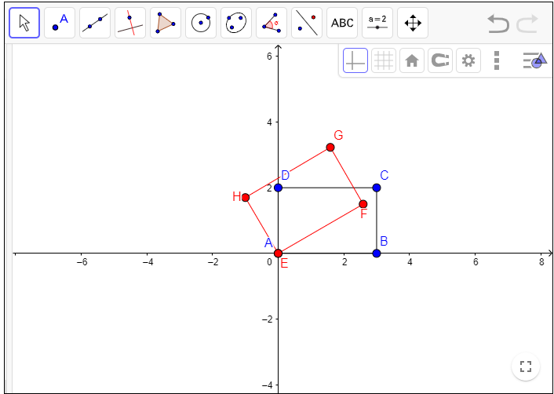
Work to do:
Q1. Sketch the image of given parallelogram with vertices A(0,1), B(3,0), C(5,-2),
D(2,-1) under the rotation of ${90}^{0}$ (anticlockwise) .
Q2. Sketch the image of given triangle with vertices A(2,4), B(2,2), C(4,2) under the
rotation of 9$0^{0}$ (clockwise) .
Example 2. Let y = 2x+5 be a line. Find the equation of line after rotating it through
an angle of $\frac{π}{2}$ clockwise direction about origin.
Solution: The matrix of rotation in clockwise direction is
$$A=\left[\begin{matrix}Cos(θ) & Sin(θ) \\ -Sin(θ) & Cos(θ)\end{matrix}\right]$$
As $θ=\frac{π}{2}$, so$$A=\left[\begin{matrix}0 & 1 \\ -1 & 0\end{matrix}\right]$$
$$and T\left[\begin{aligned}x \\ y\end{aligned}\right]=\left[\begin{matrix}0 & 1 \\ -1 & 0\end{matrix}\right]\left[\begin{aligned}x \\ y\end{aligned}\right]$$
$$or \left[\begin{aligned}x' \\ y'\end{aligned}\right]=\left[\begin{matrix}0 & 1 \\ -1 & 0\end{matrix}\right]\left[\begin{aligned}x \\ y\end{aligned}\right] =\left[\begin{aligned}y \\ -x\end{aligned}\right]$$
$$or \left\{\begin{aligned}x^{'}=y \\ y^{'}=-x\end{aligned}\right. ⇒\left\{\begin{aligned}x=-y' \\ y=x^{'} \end{aligned}\right.$$
Put value of x and y in original equation of line $y=2x+5$ and obtain
$$y^{'}=-\frac{x^{'}}{2}+\frac{5}{2}$$
This is the rotated line with angle $\frac{π}{2}$ in clockwise direction.
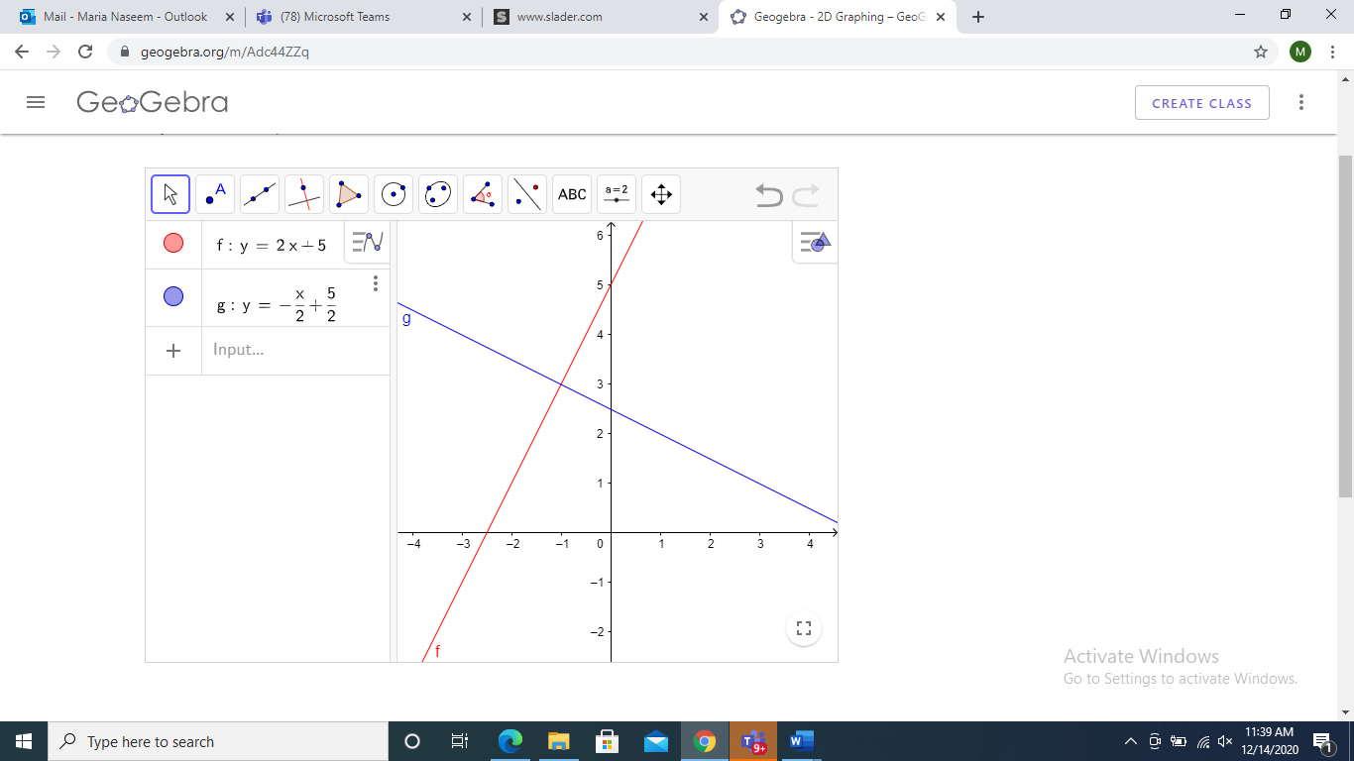
Work to do:
Q3. Let $y =-2x+7$ be a line. Find the equation of line after rotating it through an angle of ${180}^{0},{270}^{0}$ clockwise direction about origin.
Example 3. Let ${\left(x-4\right)}^{2}+{\left(y-3\right)}^{2}=9$ be a circle. Find the equation of circle after rotating it through an angle of ${90}^{0}$ in anticlockwise direction about origin.
Solution: The matrix of rotation in anticlockwise direction is
$$A=\left[\begin{matrix}Cos(θ) & -Sin(θ) \\ Sin(θ) & Cos(θ)\end{matrix}\right]$$
As $θ={90}^{0}$, so
$$A=\left[\begin{matrix}0 & -1 \\ 1 & 0\end{matrix}\right]$$
Therefore, for $T\left(\vec{x}\right)=A\vec{x } :∀ \vec{x}∈R^{2}$
$$\left[\begin{aligned}x' \\ y'\end{aligned}\right]=\left[\begin{matrix}0 & -1 \\ 1 & 0\end{matrix}\right]\left[\begin{aligned}x \\ y\end{aligned}\right]=\left[\begin{aligned}-y \\ x\end{aligned}\right]$$
Or $\left\{\begin{aligned}x^{'}=-y \\ y^{'}=x\end{aligned}\right.$ $⟹\left\{\begin{aligned}x=y' \\ y=-x'\end{aligned}\right.$
Putting these values of x and y in original equation of circle
$${\left(x-4\right)}^{2}+{\left(y-3\right)}^{2}=9$$
We get ${\left(x^{'}+3\right)}^{2}+{\left(y'-4\right)}^{2}=9$
This is the equation of rotated circle with angle $\frac{π}{2}$ in anticlockwise direction.
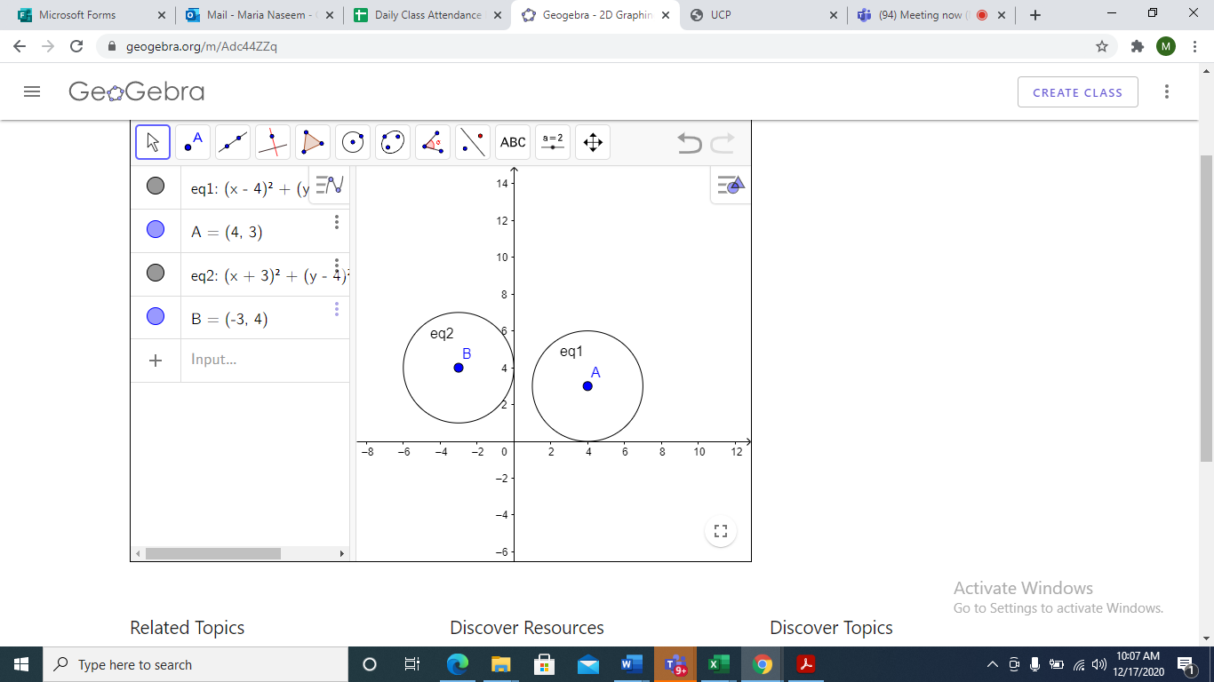
Work to do:
Q4. Let ${\left(x-4\right)}^{2}+{\left(y-3\right)}^{2}=9$ be a circle. Find the equation of circle after rotating it through an angle of ${180}^{0}, {270}^{0}$ in clockwise direction about origin.
Example 4: Let $\frac{x^{2}}{{\left(4\right)}^{2}}+\frac{y^{2}}{{\left(3\right)}^{2}}=1$ be an ellipse. Find the equation of ellipse after rotating it through an angle of ${90}^{0}$ in anticlockwise direction about origin.
Solution: The transformation of rotation in anticlockwise direction is
$$T\left(\vec{x}\right)=A\vec{x} :∀\vec{x }∈R^{2} \\ T(\vec{x})=\left[\begin{matrix}Cos(θ) & -Sin(θ) \\ Sin(θ) & Cos(θ)\end{matrix}\right]\vec{x}$$
As $θ={90}^{0}, \left[\begin{aligned}x' \\ y'\end{aligned}\right]=\left[\begin{matrix}0 & -1 \\ 1 & 0\end{matrix}\right]\left[\begin{aligned}x \\ y\end{aligned}\right]=\left[\begin{aligned}-y \\ x\end{aligned}\right]$
Hence, $\left\{\begin{aligned}x^{'}=-y \\ y^{'}=x\end{aligned}\right.$ or $\left\{\begin{aligned}x=y' \\ y=-x'\end{aligned}\right.$
Put these values of x and y in original equation of ellipse, we get the rotated ellipse with angle $\frac{π}{2}$ in anticlockwise direction as
$$\frac{{x'}^{2}}{9}+\frac{{y'}^{2}}{16}=1$$
For plotting we can neglect the dash $(‘)$ from our rotated equation of ellipse.
Original Ellipse Rotated Ellipse
$\frac{x^{2}}{16}+\frac{y^{2}}{9}=1$ $\frac{x^{2}}{9}+\frac{y^{2}}{16}=1$
Major axis is along x-axis Major axis is along- yaxis
$a=±4$,$b=±3 a=±3, b=±4$
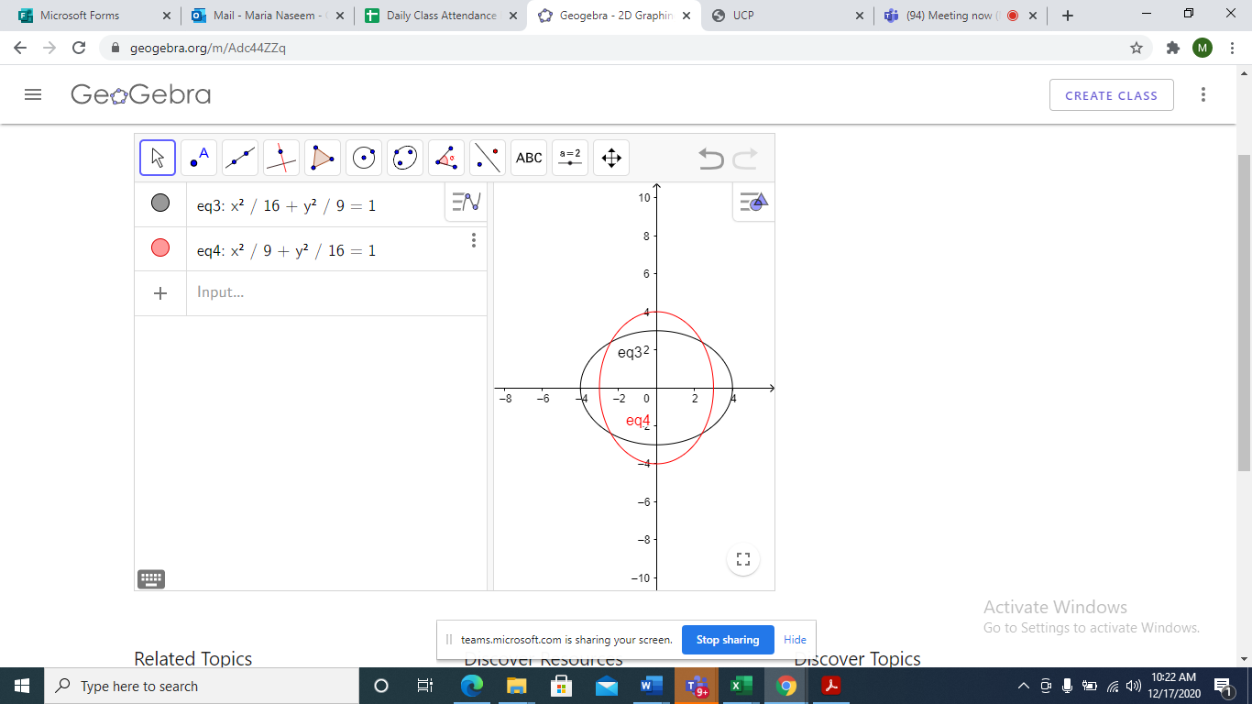
Q 5. Let $\frac{x^{2}}{9}+\frac{y^{2}}{16}=1$ be an ellipse. Find the equation of ellipse after rotating it through an angle of ${180}^{0}$ in anticlockwise direction about origin.

